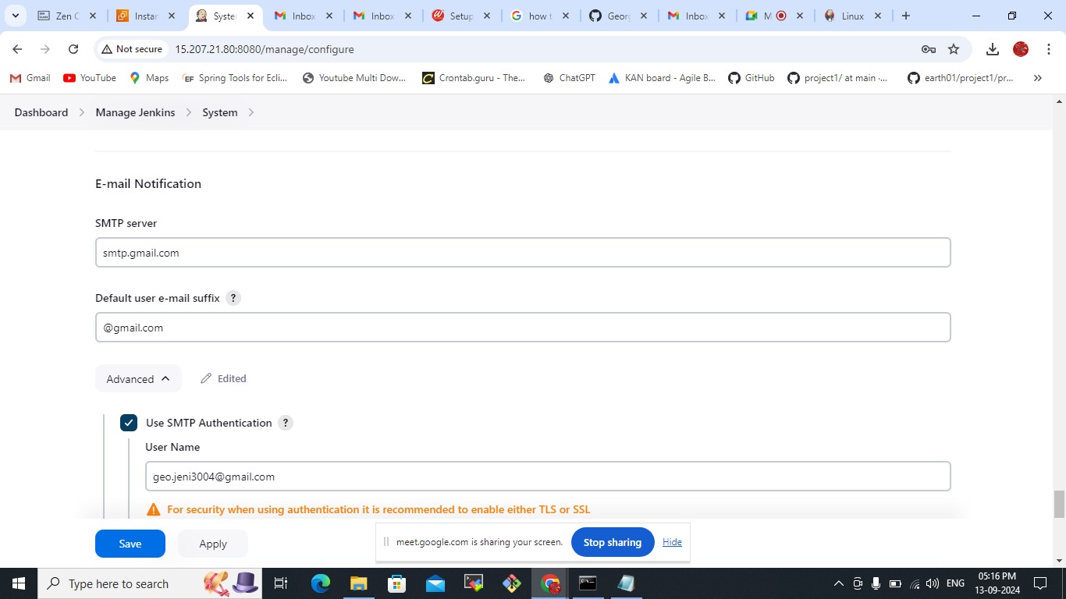  
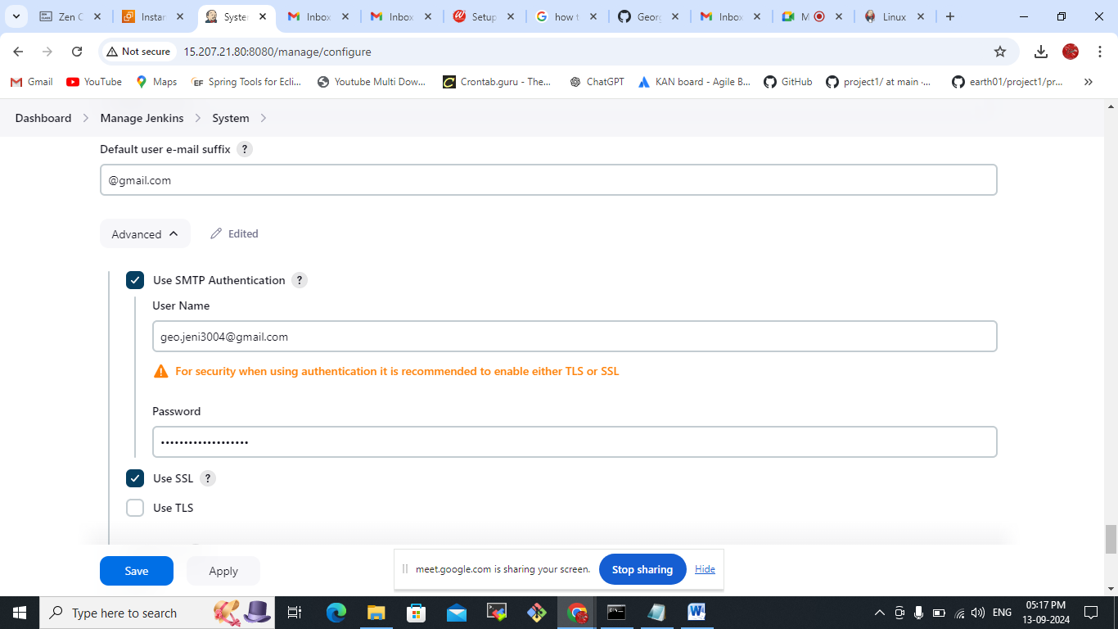  
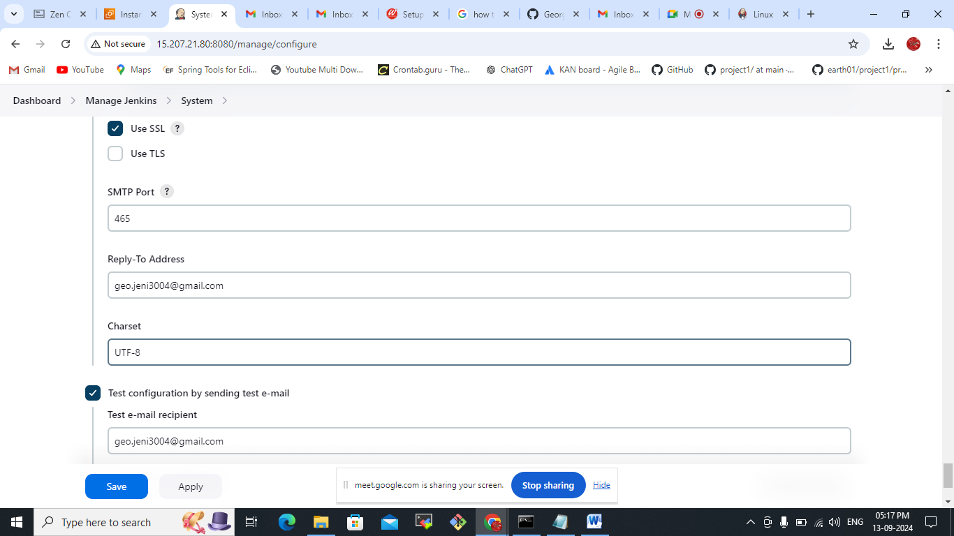  
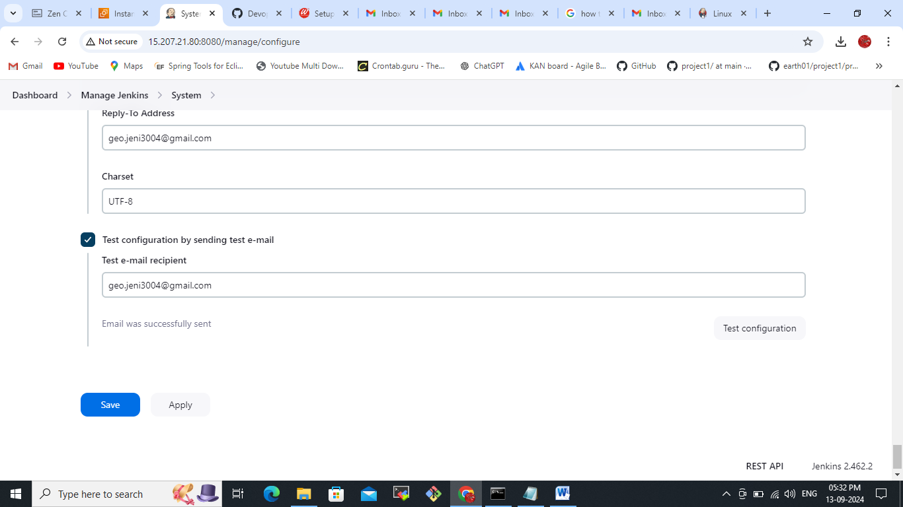  
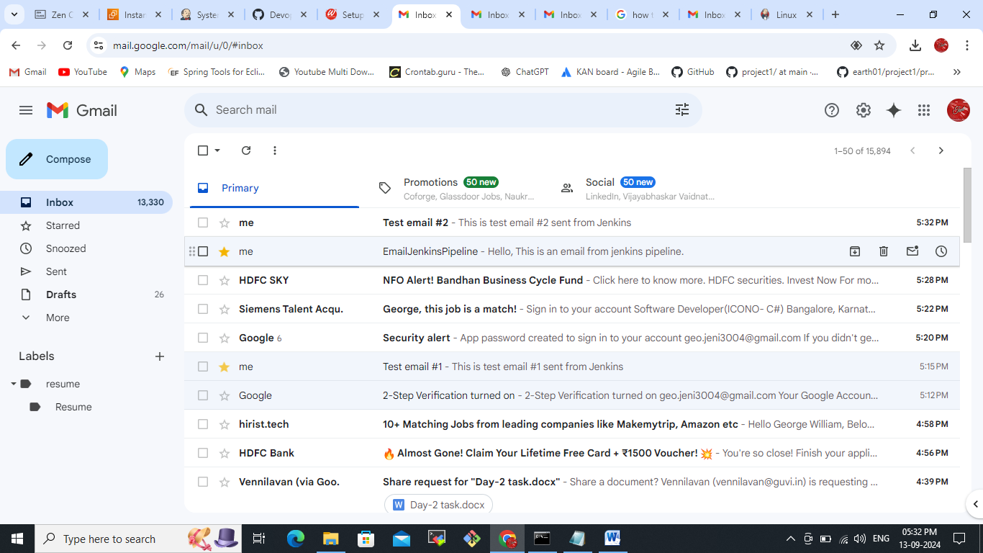

here password you need to create a password in your gmail account before that we need to enable the 2 way verification from your gmail account.  
Like type – app password  
  
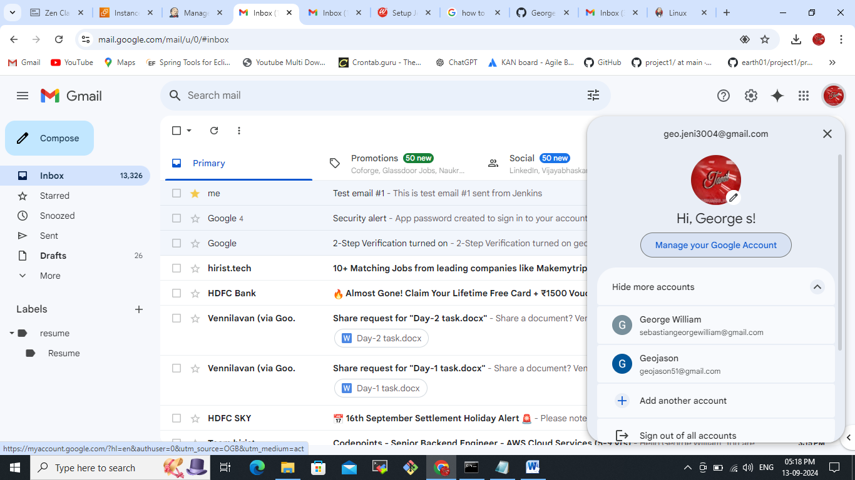

app set up in your gmail:

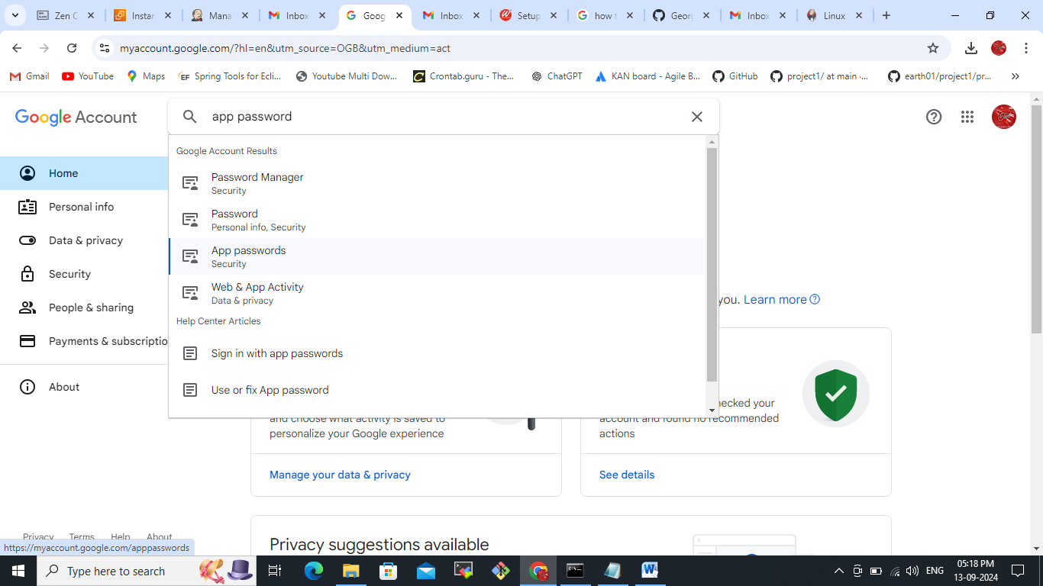  
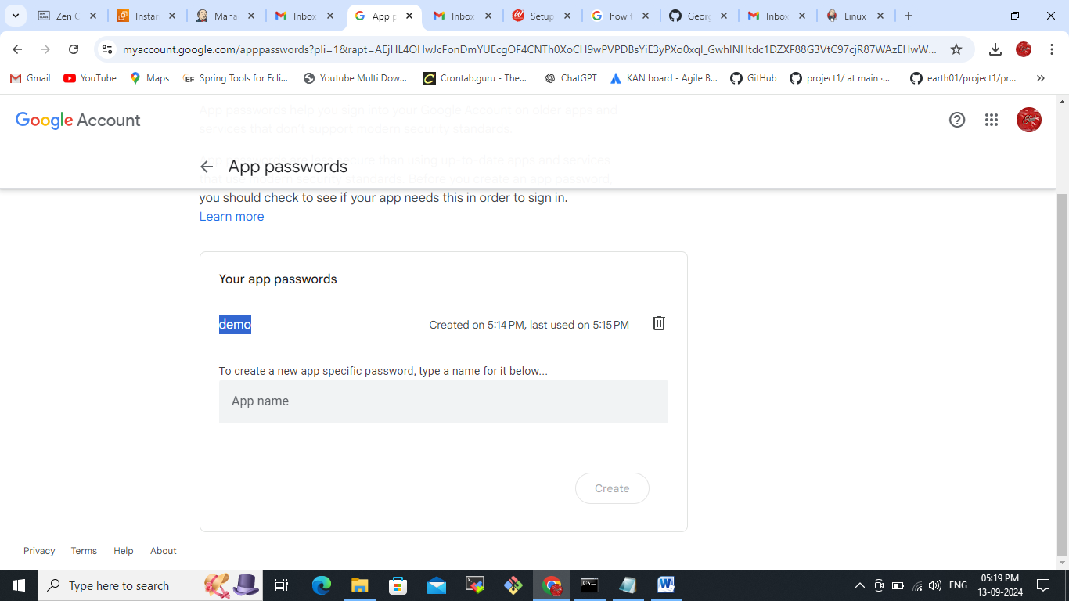  
the above already created one once you click create app name you will get immediately get popup you need to save it and paste the password screen in Jenkins

Example  
  
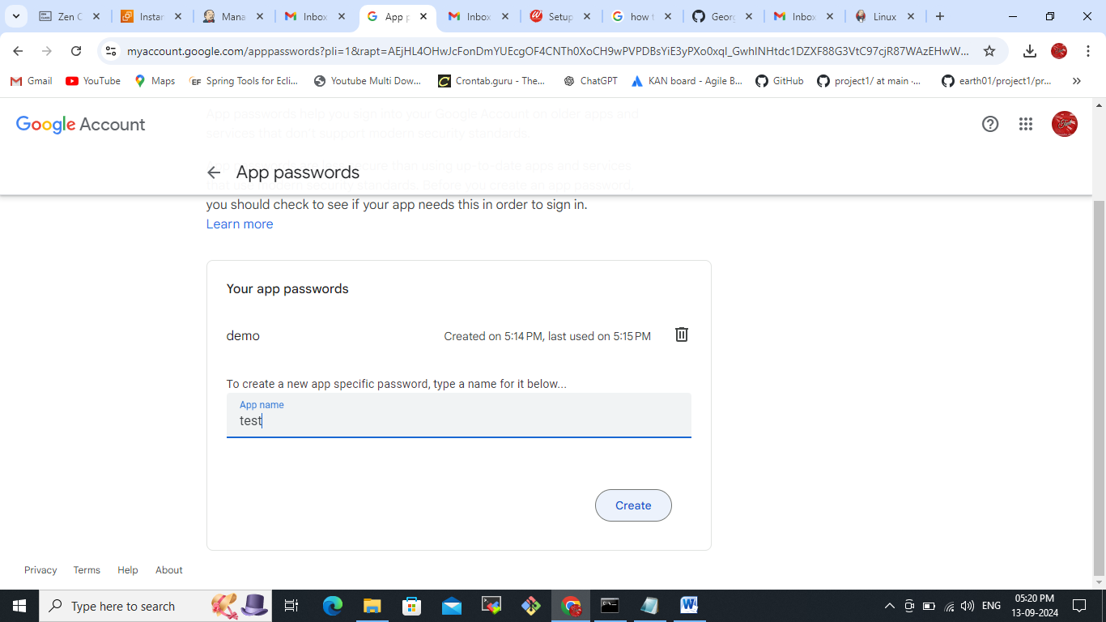  
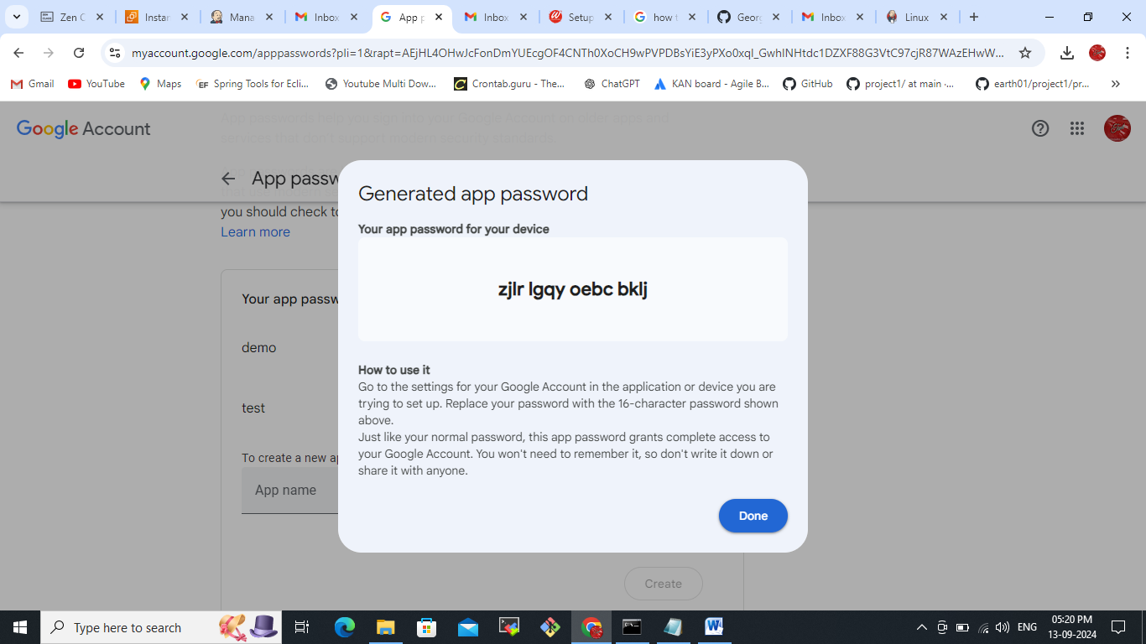This is the password  
  
Install Jenkins  
create pipeline for this email notifications  
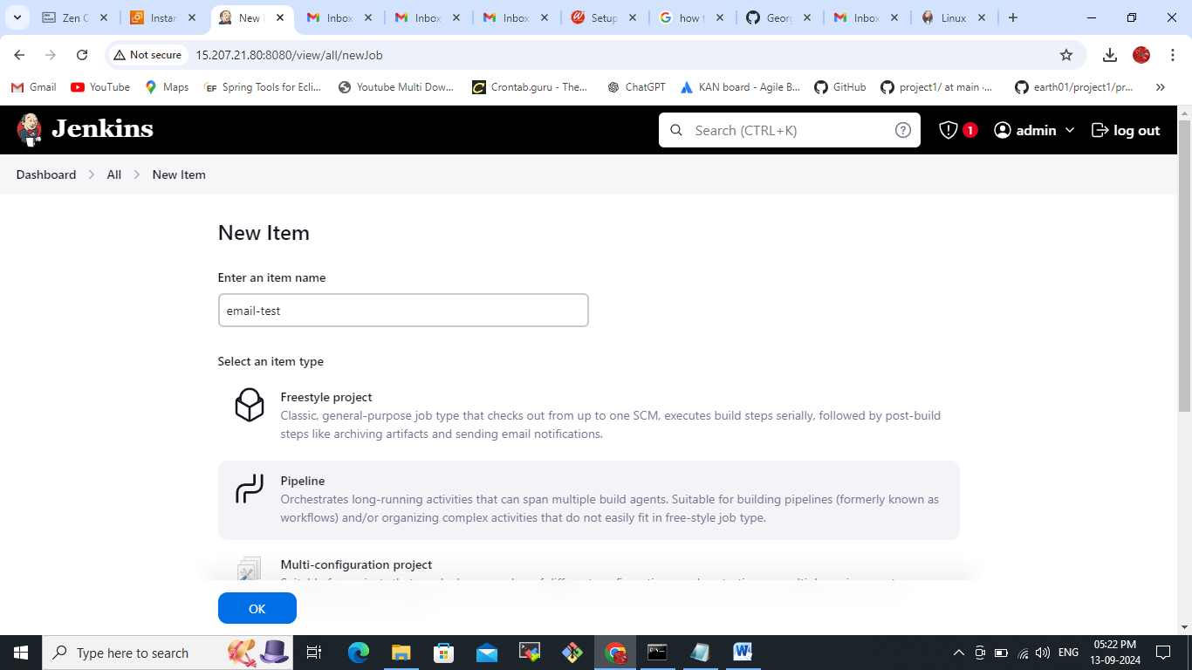  
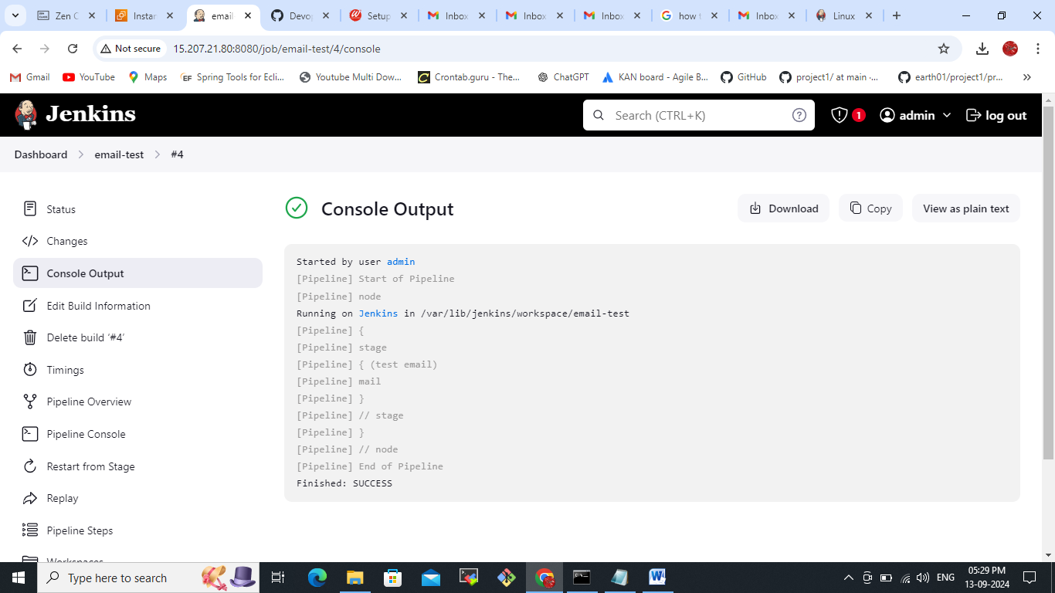  
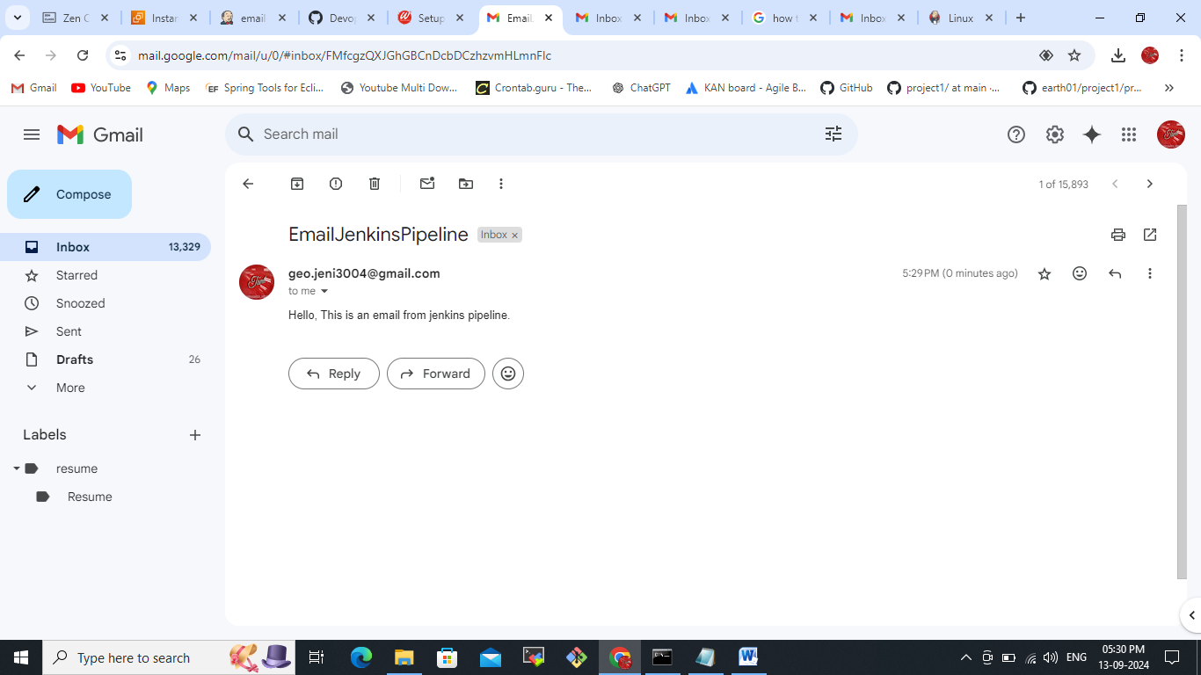  
**Pipeline script:**  
pipeline {

agent any

stages('Email Jenkins pipeline') {

stage('test email') {

steps {

mail bcc: '', body: 'Hello, This is an email from jenkins pipeline.', cc: '', from: '', replyTo: '', subject:'EmailJenkinsPipeline', to: 'geo.jeni3004@gmail.com'

} }

}

}  
